Linear Functions

Functions

- If a “machine” gives us two outputs for one given input, that “machine” is not a function
- For a function, two different inputs can produce the same output.

Linear Function

The graph of a function

Some examples

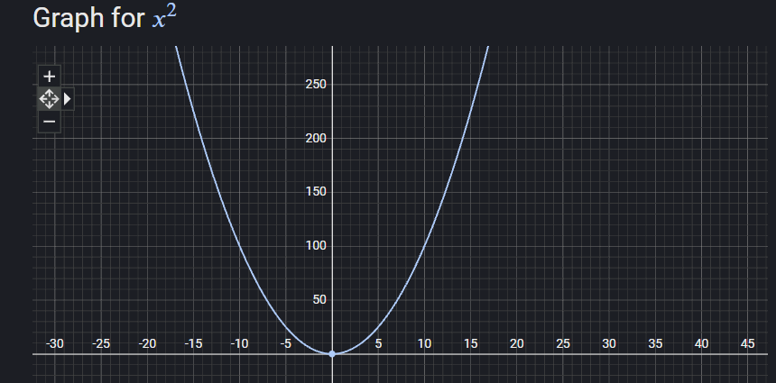

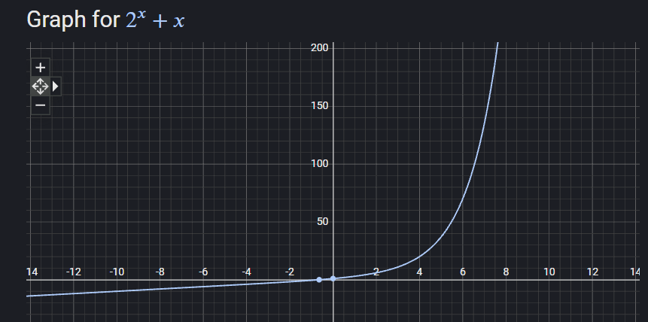

The graph of linear functions

Practice Problems

Graph the following linear functions. Make sure to show the calculations for the pairs as in the example.

- y = 3x + 2
- y = - 2x + 1

Slope

Vertical Line

Horizontal Line

Write the equation of a line

Assignment 2

- Write the equation of the line passing through (1, 3) and (0, 2)
- Write the equation of the line with slope -3 and passing through (2, 4)

